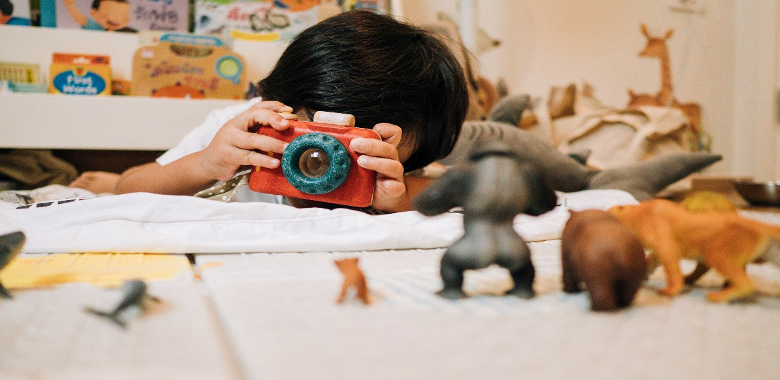

**BLOSSOM GROVE ACADEMY PHOTO RELASE FORM**

This form is for permission to display photos of your child. We like to take pictures of your child(ren)

playing and doing some special activities and then display them in the daycare center, Brightwheel app and also on Social Media (Facebook and Instagram Page).

This is a great way to share with parents what the children are doing while they are in daycare. The children really enjoy looking at pictures of their friends and themselves.

Please indicate below if we may use your child’s photograph for the use mentioned above and return

this form.

____ I grant permission to BLOSSOM GROVE ACADEMY to use my child’s photograph for the uses

mentioned above.

____ I do not give permission to BLOSSOM GROVE ACADEMY to use my photograph for any use my

child’s photograph for any use.

Child’s Name ____________________________________________________________

Parent/Guardian ____________________________Date____________________________

Parent/Guardian ____________________________Date____________________________